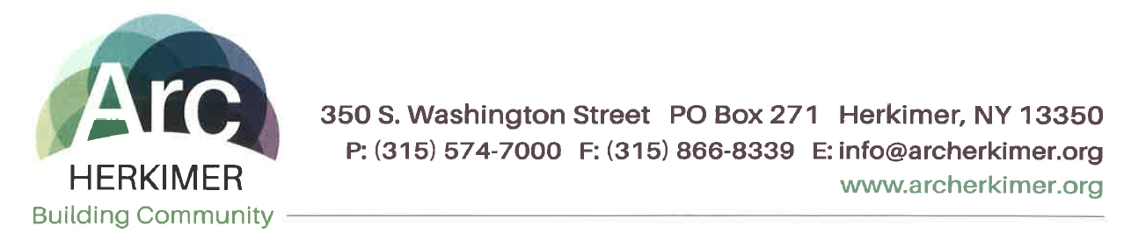
Ethics Helpline

The Corporate Compliance Officer oversees Arc Herkimer’s Ethics Helpline, a confidential secure voice mail system that is committed to timely identification and resolution of all issues that man adversely affect individuals supported, staff, and/or Arc Herkimer. People can call anonymously. Telephone calls to the Ethics Helpline might include: known episodes of misconduct or violation of agency procedures and/or questions regarding documentation or the implementation of agency policy.

To call the Ethics Helpline, dial (315) 866-7946

