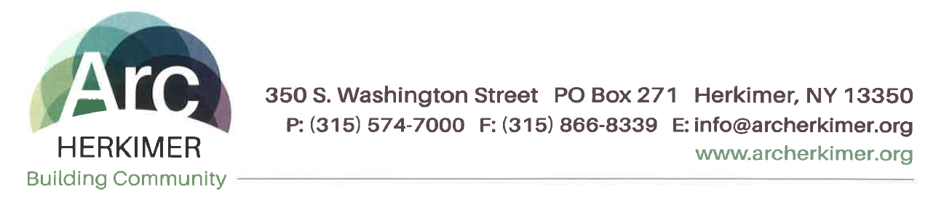
Arc Herkimer Code of Conduct

We believe that certain rules of conduct must be observed to promote a positive and ethical work environment and pledge to abide by the laws, regulations Arc Herkimer policies and procedures, including, but not limited to those related to the Arc Herkimer Corporate Compliance Plan.

We also understand that, as individuals working for and on behalf of Arc Herkimer, we have the added responsibility of following specific rules of conduct, as described below:

- To work cooperatively and respectfully with all Arc Herkimer employees, volunteers, Board members and agents to provide the highest quality of services;
- To place the interests of the people we serve and their family members first and foremost in all aspects of what we do;
- To represent Arc Herkimer positively in the community-at-large;
- To conduct all activities in a fiscally responsible manner while staying abreast of applicable regulations;
- To work in accordance with applicable laws, regulations and Arc Herkimer policies;
- To seek training and assistance in areas that would strengthen the ability to fulfill responsibilities to the individuals supported and Arc Herkimer;
- To avoid conflicts of interest and openly identify those which already exist or come into existence; including the acceptance and giving of gifts (to include relationships with individuals supported) of more than a nominal value, unlawful referrals and kickbacks;
- To conserve resources of Arc Herkimer by not engaging in wasteful behavior, which includes using agency assets for other than their intended purpose unless pre-approved;
- To treat confidentially, information related to Arc Herkimer and the individuals we support to respect the privacy of individuals supported and fellow Arc Herkimer employees;
- To complete tasks in a timely manner and meet expectations for the excellent quality of work that Arc Herkimer strives to achieve;
- To bill individuals and third-party payors accurately, honestly and comply with the Federal and New York State False Claims Acts;
- To report to a supervisor, the Corporate Compliance Officer or to the Ethics Helpline any potential violation of applicable laws, regulations and policies, including the Arc Herkimer Code of Conduct;
- To respect the role of the Board and management and to fully implement their decisions;
- To consult Arc Herkimer leadership when questions arise as to the conduct permitted under applicable laws, regulations and policies, including the Arc Herkimer Code of Conduct;
- To report and record any and all information accurately, completely and honestly.
- All contractors shall conduct themselves in accordance with high regards for ethical business practices and shall comply with applicable laws and regulations related to its work with Arc Herkimer. The contractor will never knowingly, with deliberate ignorance, or reckless disregard make or present, or cause anyone else to make or present, improper, false, or fraudulent claims to any government or private entity. All contractors must confirm that they have not been disqualified or excluded by any government agency before agreements are authorized and executed.

For a complete copy of the Arc Herkimer Code of conduct, please contact:

Jessica French, Director Compliance & Quality/Compliance Officer at
Address: 350 S. Washington Street, P.O. Box 271 Herkimer, NY 13350
Phone: (315) 574-7000
E-mail: jfrench@archerkimer.org

